Practical Exercise 10 – 2D Arrays

The following example demonstrates how to create and display the contents of a 2D array.

import java.awt.*;

import javax.swing.*;

class MyCanvas extends JPanel

{

// Daily maximums for three locations during one week

int[][] DailyMax = {

{13,12,12,11,13,11,10}, // Hobart, TAS

{31,30,30,30,29,28,29}, // Broome, WA

{9,8,11,12,12,11,9} // Canberra, ACT

};

int[] WeeklyTotal = new int[DailyMax.length];

int[] WeeklyAverage = new int[DailyMax.length];

int xPos,yPos;

public void paint(Graphics g)

{

// Calculate the averages for each town

for (int row=0; row<DailyMax.length; row++)

{

WeeklyTotal[row]=0;

for (int column=0; column<DailyMax[0].length; column++)

{

WeeklyTotal[row] = WeeklyTotal[row] + DailyMax[row][column];

}

WeeklyAverage[row] = WeeklyTotal[row] / DailyMax[row].length;

}

// Display contents of the 2D array

xPos=20;

yPos=20;

for (int row=0; row<DailyMax.length; row++)

{

for (int column=0; column<DailyMax[0].length; column++)

{

g.drawString(""+DailyMax[row][column], xPos, yPos);

xPos=xPos+30;

}

g.drawString(" Avg: "+WeeklyAverage[row], xPos, yPos);

yPos=yPos+20;

xPos=20;

}

}

}

public class ArrayDemo2D

{

public static void main(String[] a)

{

MyCanvas myCanvas = new MyCanvas();

// myCanvas.init();

JFrame window = new JFrame();

window.setDefaultCloseOperation(JFrame.EXIT_ON_CLOSE);

window.setBounds(30, 30, 400, 300);

window.getContentPane().add(myCanvas);

window.setVisible(true);

}

}

# Task 1 – Total score

Create a program (based on the example code above) that has the following global variables:

int[][] results = { {10, 30, 82, 49},

{88, 25, 72, 56},

{30, 52, 37, 49} };

// a 2D-array results with 3 students and 4 test scores for each student

int total = 0; // total of all scores

Output all these scores as a table and then, on a new line, give the total of all the scores.

Hint: You will need the following line of something equivalent somewhere in your code, but where to put it?

total = total + results[row][column];

# Task 2 – Row totals

Add the following global variable:

int[] sum = new int[3]; // total for each student

Produce a table of these scores, giving a total of the four scores for each student, as well as the cumulative total of all scores.

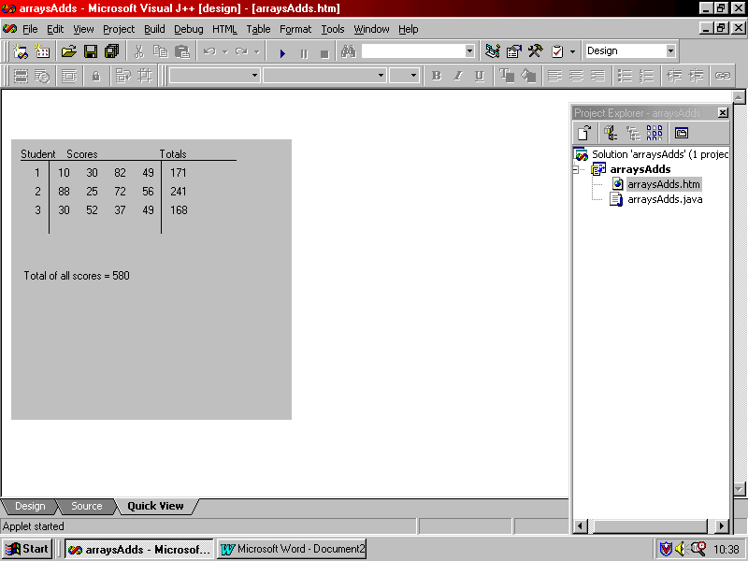Put in headings for the data, a student number in the first column and gridlines. It should resemble the output shown at the right.

To draw the lines you should use:

g.drawLine(xpos1, ypos1, xpos2, ypos2);

where xpos1, ypos1 are the start coordinates for the line and xpos2, ypos2 are the end coordinates for the line.

# Task 3 – Chess Board

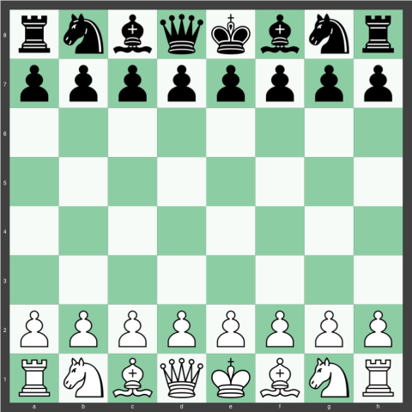Create a multi-dimensional char array to represent a standard 8x8 chessboard with the pieces in their starting positions, and output the board to the screen.

Tips:

* Use letters to represent the pieces, with lower-case for black pieces, upper-case for white. E.g. ‘k’ = black king, ‘q’ = black queen, ‘n’ = black knight, ‘K’ = white king, ‘Q’ = white queen, ‘N’ = white knight, etc.
* Use graphics methods to draw the outline of the board and fill it with the standard light and dark chessboard pattern. Note: “light is on the right”.

(image credit: chesssetup.com)

# Image result for chess starting positionTask 4 – Chess960 (stretch goal - bonus task)

Create a method to randomly generate a Chess960 starting position. Output the board to the screen.

*Chess960 is a variation of Chess invented by former world chess champion Bobby Fischer.*

*Before the game, a starting position is randomly determined and set up, subject to certain requirements. White's pieces (not pawns) are placed randomly on the first rank, following two rules:*

1. *The bishops must be placed on opposite-colour squares.*
2. *The king must be placed on a square between the rooks.*

*Black's pieces are placed equal-and-opposite to White's pieces. (For example, if the white king is randomly determined to start on f1, then the black king is placed on f8.) Pawns are placed on the players' second ranks as in standard chess.*

(<https://en.wikipedia.org/wiki/Fischer_random_chess>)